General Formatting:
- Create format in Excel
- Remove box lines
- Copy range of cells
- Paste as image in email
- Avoid sending out info as attachments
- If you are sick/absent/etc., you are required to find a replacement to get your part sent out

https://www.tradingcalendar.com/ → good resource as a daily check

Team 1
Tomorrow’s Earnings Calendar:
- Sent Daily (if applicable)
- Process:
  - Go to TTN
  - Click Calendar tab
  - Press arrow in upper left corner
  - Under “Earnings Calendar”, click on “Americas”
  - Click “Next Day” to view calendar for tomorrow
  - Press “print”
  - Save as PDF
  - Click “more settings” and enable background graphics
  - Save and send out

Prior Day/Premarket Earnings List:
- Sent daily (if applicable)
- Process:
  - Investing.com
  - Go to earnings calendar
  - Select date as yesterday
  - Click on market cap and sort from high to low
  - Click on time to sort by AH (will show the moon symbol)
  - Screenshot tickers
  - Changes date to today
  - Sort time to by daytime for premarket
  - Screenshot tickers

Add/Deletes:
- Sent when new additions/deletions hit the S&P newswire
- A reminder must be sent out the morning of the effective date (i.e. add/delete date is 7/5 afterhours → email must be sent on the morning of 7/5)
- Process:
  - Use the following:
    - https://www.spglobal.com/spdji/en/indices/equity/sp-500/#news-research
    - https://www.spglobal.com/spdji/en/media-center/news-announcements/#indexNews

Lock-Up/Quiet Period Expirations:
- Sent at beginning of month and daily (if applicable)
- Process:
  - Marketbeat.com
  - Go to “Financial Calendars”
  - Under “Corporate Events” use “IPO Lockup Expirations” and “IPO Quiet Period Expirations”

M&A News (move analysis, terms, additional bidders, closing dates, CVRs, etc.):
- Sent 2x day
- The first e-mail around 9am with M&A news up until that point in time, the second after the close. The second e-mail should include anything from the morning e-mail as well as deals announced during the day.
- Process:
  - Look at https://seekingalpha.com/market-news/m-a and TradeTheNews premarket movers for any definitive M&A headline (takeover chatter is a separate job). Can use other sources obviously, but these caught all the important headlines when I did it.
  - For each headline, put the tickers involved and how much they have moved from the headline
  - Give a couple bullet point summary of the headline
  - Make sure to include deal terms based on what type of deal it may be:
    - If cash, include the cash value and share price.
    - If stock, include the number of shares of stock X for number of shares of stock Y.
    - If cash and stock, include the cash portion (you may need to do some math to back into a stock price) AND the stock ratio
  - Put the key numbers and information in bold.
- Example:
BCAL +14% CALB no volume
- Southern California Bancorp (NASDAQ:BCAL), the holding company for Bank of Southern California, and California BanCorp (NASDAQ:CALB) announce merger agreement
- The companies will combine in an all-stock merger valued at ~$233.6M, or $26.54 per share of CALB
- Each outstanding share of CALB common stock will be exchanged for the right to receive 1.590 shares of BCAL common stock

Team 2
Secondary Offerings (announcements and calendar dates):
- Use TTN
- Search for terms: offering, secondary, etc. to find
- Send out all terms

Splits and Large Dividends:
- Sent daily (if applicable)
- Process (dividends):
  - Go to Investing.com
  - Go to earnings calendar
  - Go to dividends
  - Filter
  - Scroll down and click 3 stars
  - Go back and choose date as today
  - Screenshot tickers
- Process (splits):
  - Go to https://finance.yahoo.com/calendar/splits
  - Select date
  - Double check list against https://www.nasdaq.com/market-activity/stock-splits
  - Screenshot tickers

Takeover Chatter Tracker (rumors or chatter headlines, move analysis):
- Sent daily (if applicable)
- Process:
  - Tracking of any M&A or Activist chatter from any and all news sources (use the following, but the list is not limited to just these entries:
    - Street Insider
    - Activist Insight

Team 3
Spin-offs/Symbol Changes/De-SPACs:
- Sent daily (if applicable) with description of ticker change or spin-off
- Process Symbol Changes:
  - Use TTN
  - Search “ticker change” or “symbol change”
  - Ask any of your favorite LLMs (Perplexity, ChatGPT, Claude, etc.)

Find every U.S.-listed (Nasdaq, NYSE, NYSE American, NYSE Arca, Cboe) symbol
change effective at today's open, [DATE]. Cover all of these event types,
searching separately for each:

1. Straight ticker/name changes ("will begin trading under the new symbol")
2. De-SPAC closings ("completes business combination", "closes merger with
[X] Acquisition Corp", "begins trading on Nasdaq under"), including SPACs
that closed in the last 1-2 trading days
3. Reverse mergers and reorganizations into a new holding company
4. Changes to units, warrants, rights, and preferred shares (U/W/R/P suffixes)
5. Exchange transfers, even when the ticker stays the same

Also search SEC filings from the last 3 trading days: 8-K Item 2.01
(completed acquisition), Item 3.03/5.03 (name/charter changes), Form 25
(delisting of the old SPAC symbol), and 6-Ks for foreign issuers.

For each one, give: old ticker -> new ticker, company name, effective date,
exchange, affected security classes (common/units/warrants/rights), and
whether the CUSIP changes. Cite the source.

Then list anything effective in the next 5 trading days.

Finally, state plainly that news search is not exhaustive and name what
to check against (Nasdaq Trader daily symbol changes, NYSE corporate actions).

- Process Spin-Offs:
  - Explanation of spin-off and details of the spun-off company
- Process De-SPACs:
  - LLM prompt: Give me a list of De-SPACs looking forward 1 month
  - You may have to follow up on these as they do not all have exact dates yet but rather ranges depending on how far out they are.
  - We want these sent out once we have an exact date, then on the exact date as well

Biotech Calendar (PDUFAs, ADCOMs, expected trial dates, etc.):
- Calendar to be sent at the beginning of the month and week
  - If events happen before the date, remove name off list.
- Use Bloomberg Biotech Catalyst Calendar and Biopharm Catalyst
- Symbol, Catalyst, Company Name(s), Source Type, Drug Broad Indication, Expected Date
- Use the following as an example for formatting: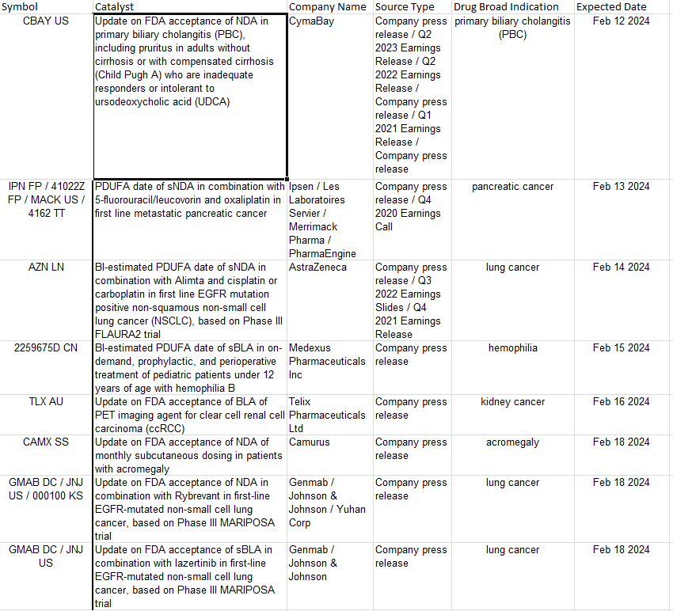

Short Report Tracker (move analysis, synopsis, etc.):
- Sent when applicable by EOD the following day
- Process:
  - Find and read report
  - Top line of email is the author’s name (i.e. Citron) followed by a link to the report
  - Include ticker, price target, release method, move analysis (% move from release to close and closing price), synopsis of report

Team 4
IPOs/Closed End Funds/Uplistings:
- Sent daily (if applicable)
- Many IPOs/Uplistings will price late the night before or early the morning of - it is important to continue checking our sources for new listings up during premarket trading
- Uplisting Process
  - https://www.nasdaq.com/market-activity/ipos
  - LLM Prompt: Give me a list of upcoming uplistings that are to be listed on NYSE or NASDAQ
- Closed End Fund Process
  - LLM Prompt: Give me a list of upcoming closed end funds that are to be listed on NYSE or NASDAQ
  - Find the top holdings and list them out
  - Important to note any notable holdings the fund may hold
- IPO Process:
  - Most reliable website to check for eligible IPOs is https://www.iposcoop.com/ipo-calendar/ and you can double check on https://www.marketwatch.com/tools/ipo-calendar and https://www.nasdaq.com/market-activity/ipos
  - From there, you can get all of the information to fill out a ticker, offer price, price range, shares (in millions), indication time, underwriters, location, industry, and description from the IPO scoop website, if you just click on the name of the stock.
- IPO Example:
Unusual Machines, Inc. - NYSE American
Ticker: UMAC
Offer Price: $4.00
Price Range: $4.00 - $4.00
Shares (in millions): 56.0
Indication Time: n/a
UnderWriters: Dominari Securities/ R.F. Lafferty & Co./ Revere Securities
Location: San Juan, Puerto Rico
Industry: Drone Services - Radio & TV Broadcasting Services & Equipment
Description:
We are a drone technology company focused exclusively on FPV (first person view) goggles to serve FPV pilots. (Incorporated in Puerto Rico)

Headquartered in Puerto Rico, we intend to build both organically and through strategic acquisitions, by targeting companies within the highly fragmented drone industry that have valuable intellectual property, revenue generating customers, and exceptional teams.

On Nov. 21, 2022, we entered into a Share Purchase Agreement with Red Cat Holdings, Inc. and Jeffrey Thompson, the founder and Chief Executive Officer of Red Cat, in which we agreed to purchase Red Cat’s consumer business consisting of Fat Shark and Rotor Riot. Fat Shark and Rotor Riot are in the business of designing and marketing consumer drones and first-person-view (“FPV”) goggles. Rotor Riot is also a licensed authorized reseller of consumer drones manufactured by third-parties. The purchase price: $18 million

Fat Shark is a leader in FPV, designing and manufacturing ultra-low latency FPV video goggles for drone pilots, which it markets towards retail distributors, including Rotor Riot. Rotor Riot is a rapidly growing e-commerce marketplace, backed by the largest community of FPV drone pilots in the world, and markets drones and drone-related products including Fat Shark goggles and competitor offerings, to end users of the drones and drone products, including drone enthusiasts, hobbyists and competitive racers. Over the next two years, we expect that these businesses will continue to excel in the consumer FPV market, while expanding into new enterprise verticals like public safety and drone delivery. This is part of our vision to enable people to be part of the robotics revolution.

Economic Reports Calendar (CPI, PPI, Jobs, bond auctions, etc.):
- Sent daily (if applicable)
- Process:
  - TTN
  - Click “Calendar”
  - Copy/paste the economic calendar for the day and be sure it’s formatted correctly in email

Daily Conference Calls/Events Calendar:
- Sent daily (if applicable)
- Process:
  - TTN
  - Click “Event Watch”
  - Scroll to “company events” and make list of all important events of the day
  - Copy/paste the events for the day and be sure it’s formatted correctly in email

Focused Earnings Analysis for Selected Names:
- Sent daily (if applicable)
- Process:
  - short interest - fintel or maverick
  - cc time - TTN or charts, use 4 previous earnings as data, if inconsistent time then give range
  - last reported date - investor relations or charts or ttn
  - options - yahoofinance or options ai
  - earnings - bloomberg
  - 52 week range - yahoofinance or maverick
  - PE/FPE - yahoofinance or maverick
  - Time of earnings - ttn or charts
- Specific Ticker Info:
  - GOOGL: add in TAC and ex-TAC numbers

Team 5
Daily Top Gainers/Losers:
- Sent daily
  - Email to be sent daily at EOD
  - News to be added to Google Sheets page
    - Monthly tabs (Jan 2025)
    - https://docs.google.com/spreadsheets/d/1Q_9kIoM2KfDqmwhT2GfGsTgtRzebBOaPcJNUEP111KQ/edit?gid=0#gid=0
- Keep daily running list of the following:
  - Major headlines
    - Related stocks
    - % and $ move
      - Note stocks high/low of move and where it settled
      - List tickers in highest to lowest order
    - How to tell it's a major headline:
      - Market cap > $1B
      - Higher than average volume
      - Headline makes it to CNBC
      - Headline moves several stocks
- Format:
Top Gainers:
LPNT: +16.20 +33.82%
To be acquired by RCCH Healthcare Partners for $65.00/shr valued at $5.6B inc debt; APO plans to merge LifePoint with RCCH HealthCare Partners, folding two health-care providers into the same company.

HAS:
Q2 EPS and revenue results came in well above estimates

RETA: +3.73 +8.04%
Reata Pharmaceuticals Says 2 Studies Suggest Bardoxolone Methyl Can Delay or Prevent Kidney Failure

SYNT: +1.42 +3.63%
Acquired by French technology service company Atos for $41 per share in cash, a premium of about 4.8 percent over the company’s Friday closing price. The total value of the deal, including assumed debt, is about $3.57 billion.
Top Losers:
​RGTI -49% QUBT -49% IONQ -43% LAES -35% QMCO -28%
Jensen Huang says quantum computing won’t be around for another 10 years.

ITW: -8.84 -6.02%
Q2 EPS and revenue come in slightly below estimates; Cuts FY18 EPS and operating margin

FCAU: -.55 -2.90%

RACE: -6.36 -4.55%

CNHI: -.17 -1.66%
Sergio Marchionne has stepped down as chairman and CEO of automakers Fiat Chrysler (FCAU) and Ferrari (RACE) and as chairman of industrial vehicle manufacturer CNH Industrial (CNHI) due to unexpected complications from surgery.

TSLA: -10.90 -3.44%
(TSLA has sent a memo to its suppliers asking them to refund a portion of what the electric car maker has
already spent to help it become profitable, the Wall Street Journal reported.

Trade Category Write-Ups:
- Will present in first week of following month over zoom to entire class + other traders who join
- Do not present repeat trades, speak w/ team to make sure no one is doing the same trade
- Each presentation is to be uploaded to the folder in Teams:
- Trade Categories to choose from:
  - Easiest trade of the week
  - Best trade of the week (based on most traders over $2k/$10k)
  - Biggest trap of the week
  - News trade of the week
  - Order flow trade of the week
  - Macro trade of the week
- Format:

[TITLE OF TRADE WRITEUP]

I. Intro
- What is the trade?
- Why are we trading it?

II. The Trade
- What did I do?
- Why/Where did I get in?
- Why/Where did I get out?
- What should I have done?
- What did others do successfully? Why?
- Did I stick to my rules? Part of my Playbook?
- Was there anything unique to this trade (box, chart pattern, etc)

III. The Takeaway
- What can we learn from the trade?
- How can we do better next time?
- Why does this qualify as [insert theme/topic]?

[CHARTS WITH ANNOTATIONS]

Current Teams

Team 1
- Gabriel Malka – Miami
- Matt Weaver – NY
- Nick Edler – Miami
- Adit Saxena – NY
- Jonathan Ovnanyan – Chicago

Team 2
- Zac Maurer – Miami
- Tristan Rowland – NY
- Henry Carnes – NY

Team 3
- Fabio Carnline – NY
- Josh Glynn – Miami
- Darius Rezaei – NY
- Luke Broering – NY

Team 4
- Drew Laake – NY
- Mike Lund – NY
- Dominick Angellotti – Chicago
- Khiem Doan – NY
- Aras Curukcu – NY
- Dylan Ajello – NY
- Shaan Vatti – NY
- Antonio Medone – NY
- Emre Sevindik – NY
- Liam Conrad – NY

Team 5
- Ivan Fediv – Chicago
- Will Titus – NY

